**Blog 6**

I read one research papers in this week.

# Contact tracing: Can ‘Bigtech’ come to the rescue, and if so, at what cost?

**Link to wiki:**

<https://github.cs.adelaide.edu.au/2020-Mobile-and-Wireless-Systems/CovidGuard-F/wiki/LOKESH-PATHAK--Contact-tracing:Can%E2%80%98-Bigtech%E2%80%99-come-to-the-rescue,and-if-so,-at-what-cost%3F>

**App Development Progress:-**

**Link to Commit-** <https://github.cs.adelaide.edu.au/2020-Mobile-and-Wireless-Systems/CovidGuard-F/commit/4a427c25a0a55f19c43d69ece9b9424f97713458>

1. Establishing SQLite connectivity to the android application
2. Store the TEKs while they are generated by the app.
3. Store the first corresponding ENInterval , so that the TEK and the ENInterval can be used to regenerate the RPIs.
4. Store everything in a table with timestamp, so that it can be uploaded to the server.
5. Made some UI changes , so that the application is responsive . This will ensure that the application text ,images, buttons remain uniform on phones of varying screen sizes.

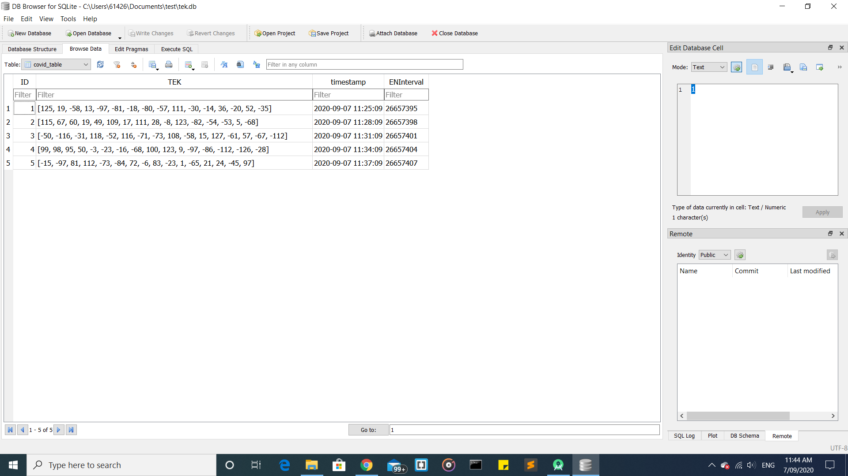

**Screenshots of TEK table and ENInterval:-**

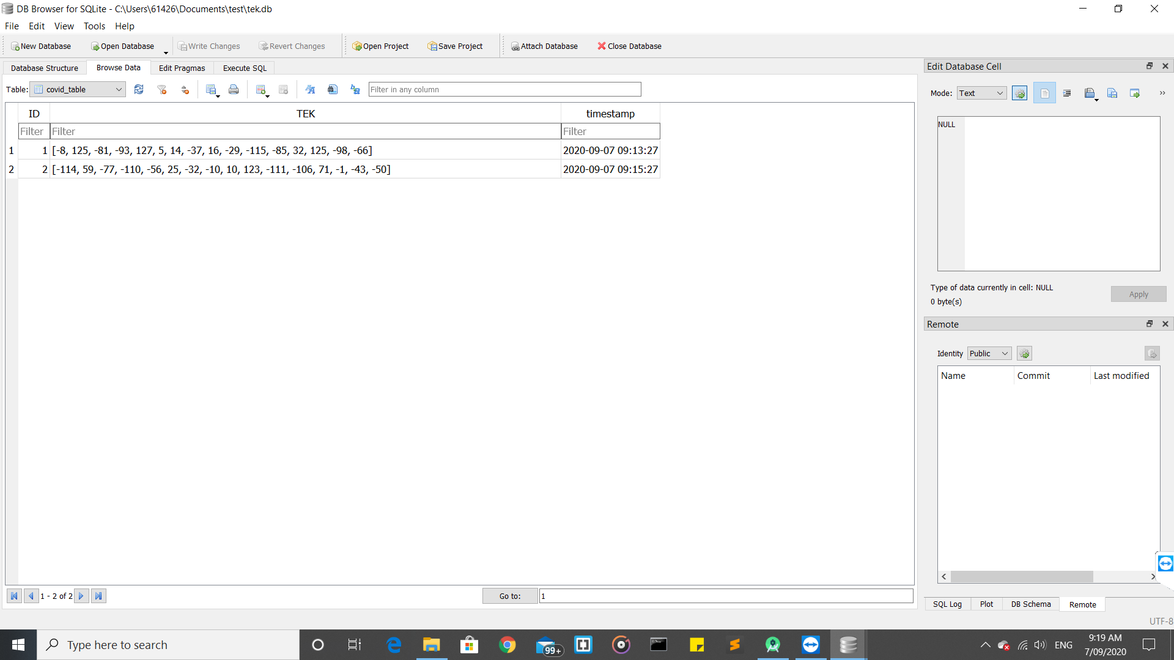

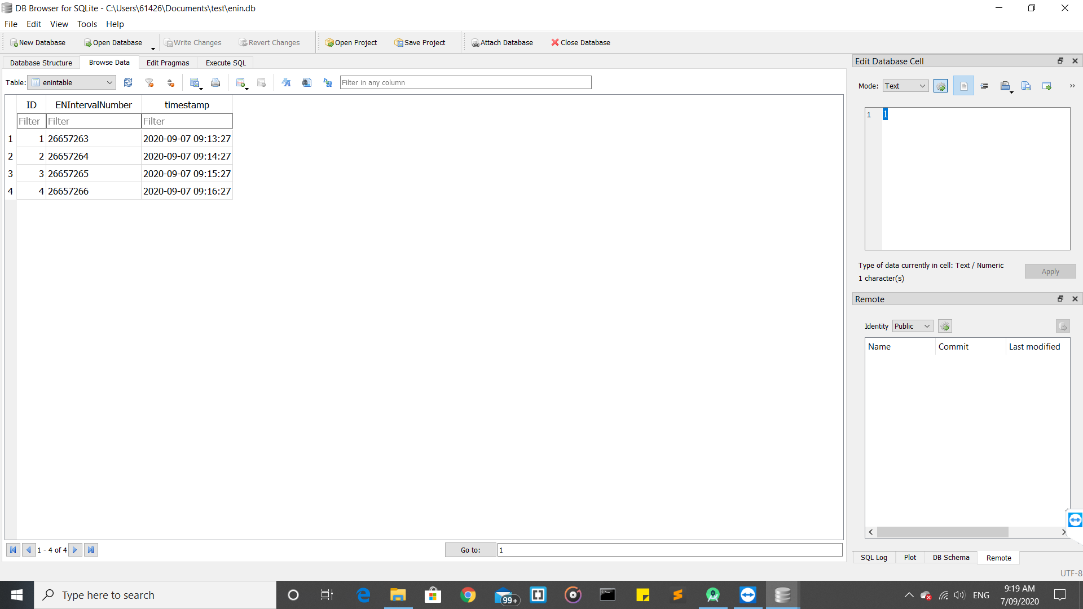

**Reason for storing only the first ENInterval of each TEK:-**

1. TEKs are generated every day or 1440 minutes while ENInterval has 144 unique value in a day as it is generated every 10 minutes. First ENInterval of each TEK is sufficient to regenerate all the RPIs generated during the 24 hours. As we have to store TEKs of 14 days, storing all the ENInterval numbers can increase storage size and make the app slow.

**Plan for this week-**

1. Look into ways to keep only the TEKs and ENInterval numbers of the last 14 days